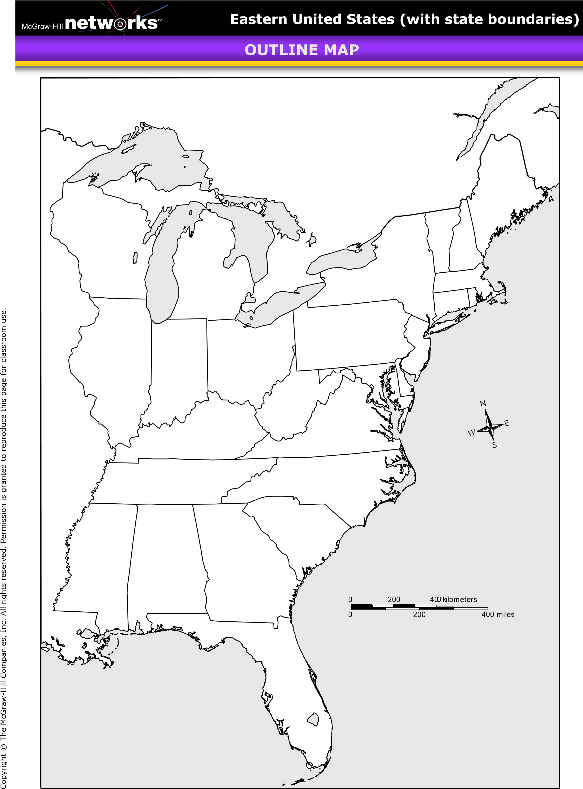
MAP OF THE COLONIES NAME: __________________
RUBRIC FOR MAP OF THE COLONIES

Instructions: Complete the following instructions using your text took or other online resources.
- Textbook pages: RA 4,5, 7, & 9 and pages: 67, 71, 76.
- Online textbook: “Atlas Tab” choose U.S. maps.
- Online textbook: Chapter 3, Sections 2, 3, & 4.

_____ 13 Label all 13 colonies, abbreviations are acceptable (some borders of colonies may vary). DO NOT COLOR INDIVIDUAL COLONIES

_____ 6 Color each of the land areas. COLOR EACH AS INSTRUCTED
Color Yellow: New England Colonies
Color Green: Middle Colonies
Color Orange: Sothern Colonies
Color Blue: Spanish Florida
Color Red: Canada
Color Tan: All areas not labeled

_____ 7 Label the following bodies of water: Each of the 5 Great Lakes, 1 Ocean, & 1 Gulf.
DO NOT COLOR WATER
_____ 6 Trace & label with a blue pen the following rivers: Mississippi River, Ohio River, and the St. Lawrence River

_____ 2 Draw in (^^^^^^) to resemble mountains and label the Appalachian Mountains

_____ 16 Locate & label the following cities by placing a dot at their location: Boston- MA, Salem- MA, Plymouth- MA, Providence- RI, Hartford- CT, New York City- NY, Philadelphia- PA, Baltimore- MD, Washington D.C., Jamestown- VA, Raleigh- NC, Charleston- SC, Savannah- GA, St. Augustine- FL

_____ 50 POINTS

_____ -5 NOT COLORED

_____ -5 NOT NEAT

